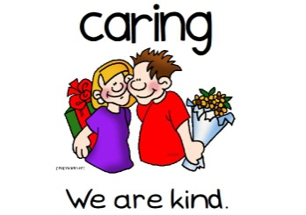[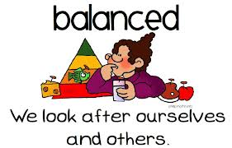](http://www.google.com/imgres?hl=en&tbo=d&rlz=1G1TSNA_ENUS412&biw=1280&bih=657&tbm=isch&tbnid=AULTbLAO9K2XjM:&imgrefurl=http://englishatalmanhal.blogspot.com/2012/09/learners-profile.html&docid=ki-VVd5Zs59rvM&imgurl=http://1.bp.blogspot.com/-ELRZjxzR63M/UFNuz5HJbyI/AAAAAAAAAAM/4--WaFUigFU/s1600/balanced.jpg&w=781&h=500&ei=KtyjUN_3C8Wa0QH30oDYBA&zoom=1&iact=hc&vpx=517&vpy=324&dur=1313&hovh=180&hovw=281&tx=169&ty=68&sig=112819198438498224887&page=2&tbnh=112&tbnw=175&start=21&ndsp=30&ved=1t:429,r:26,s:21,i:226)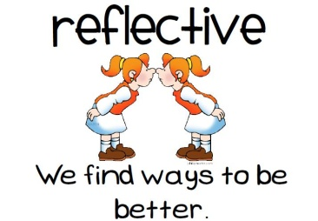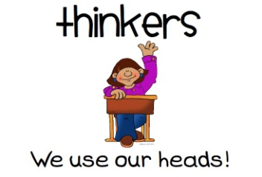[](http://www.google.com/imgres?hl=en&tbo=d&rlz=1G1TSNA_ENUS412&biw=1280&bih=657&tbm=isch&tbnid=ITOhFGaEZuOBQM:&imgrefurl=http://englishatalmanhal.blogspot.com/2012/09/learners-profile.html&docid=ki-VVd5Zs59rvM&imgurl=http://1.bp.blogspot.com/-dzS7Gpz731k/UFNu3N4yv2I/AAAAAAAAAAc/CiwgoWrIaKo/s1600/communicators.jpg&w=787&h=475&ei=jdijUKu5K-fG0wHntYHABw&zoom=1&iact=hc&vpx=2&vpy=364&dur=2016&hovh=174&hovw=289&tx=125&ty=161&sig=112819198438498224887&page=1&tbnh=112&tbnw=186&start=0&ndsp=21&ved=1t:429,r:14,s:0,i:117)[](http://www.google.com/imgres?hl=en&tbo=d&rlz=1G1TSNA_ENUS412&biw=1280&bih=657&tbm=isch&tbnid=AULTbLAO9K2XjM:&imgrefurl=http://englishatalmanhal.blogspot.com/2012/09/learners-profile.html&docid=ki-VVd5Zs59rvM&imgurl=http://1.bp.blogspot.com/-ELRZjxzR63M/UFNuz5HJbyI/AAAAAAAAAAM/4--WaFUigFU/s1600/balanced.jpg&w=781&h=500&ei=KtyjUN_3C8Wa0QH30oDYBA&zoom=1&iact=hc&vpx=517&vpy=324&dur=1313&hovh=180&hovw=281&tx=169&ty=68&sig=112819198438498224887&page=2&tbnh=112&tbnw=175&start=21&ndsp=30&ved=1t:429,r:26,s:21,i:226)[](http://www.google.com/imgres?hl=en&tbo=d&rlz=1G1TSNA_ENUS412&biw=1280&bih=657&tbm=isch&tbnid=ITOhFGaEZuOBQM:&imgrefurl=http://englishatalmanhal.blogspot.com/2012/09/learners-profile.html&docid=ki-VVd5Zs59rvM&imgurl=http://1.bp.blogspot.com/-dzS7Gpz731k/UFNu3N4yv2I/AAAAAAAAAAc/CiwgoWrIaKo/s1600/communicators.jpg&w=787&h=475&ei=jdijUKu5K-fG0wHntYHABw&zoom=1&iact=hc&vpx=2&vpy=364&dur=2016&hovh=174&hovw=289&tx=125&ty=161&sig=112819198438498224887&page=1&tbnh=112&tbnw=186&start=0&ndsp=21&ved=1t:429,r:14,s:0,i:117)

**WCB Learner Habits**

***We strive to be…***

**WCB Learner Habits**

***We strive to be…***